Literacy support worksheet

5.1 Thermal energy moves down the temperature gradient

Pages 96–97 and 206

Thermal energy moves from hot to cold

1 What is thermal energy?

2 How can energy be transferred?

3 When will moving down the temperature gradient be stopped?

4 Can energy ever be lost or gained? Explain why.

5Which molecules have: most, moderate or least space between particles; most, moderate or least movement; and most, moderate or least thermal energy?

|  |  |  |  |  |  |
| --- | --- | --- | --- | --- | --- |
| a |  | b |  | c |  |
|  | L:\1. Publishing and Editorial\1. Product\Oxford Science\Oxford Science 9\3. Extras\8. Student worksheets\Artwork\images for Julia\JPEGs\SW0501_01026-r.jpg |  | L:\1. Publishing and Editorial\1. Product\Oxford Science\Oxford Science 9\3. Extras\8. Student worksheets\Artwork\images for Julia\JPEGs\SW0502_01026-r.jpg |  | L:\1. Publishing and Editorial\1. Product\Oxford Science\Oxford Science 9\3. Extras\8. Student worksheets\Artwork\images for Julia\JPEGs\SW0503_01026-r.jpg |
|  |  |  |  |  |  |
|  |  |  |  |  |  |

6 An open and half empty plastic 2 L water bottle was left out on a hot day. The bottle was then sealed and placed in the freezer overnight.

a What does the bottle look like when it comes out of the freezer?

bWhy does it look like this?

7 Draw the structure of the atoms of a metal when cooler and warmer.

|  |
| --- |
|  |

8 A metal spoon is in constant motion, even though you can’t see it. Why is this?

9 Why do metals expand when hot?

10 If a substance were perfectly insulated, what would happen?

11 Some boiling water is added to a room temperature mug.

a What is the temperature gradient?

b When will the mug of water reach thermal equilibrium? (Hint: what two things are of different temperatures?)

WORD DETECTIVE

12 Find a word

Find the words in the puzzle of letters below that will fit the clues given.

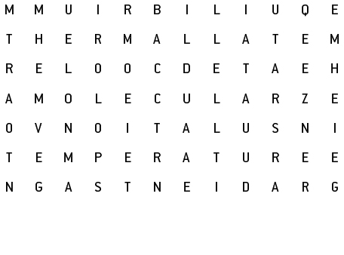

|  |  |
| --- | --- |
| WORD | CLUE |
| T\_ \_ \_ \_ \_ \_ | \_\_\_\_\_\_\_\_\_ energy is the energy of moving/vibrating particles. |
| C\_ \_ \_ \_ \_ | Thermal energy can be transferred from hotter objects to \_\_\_\_\_\_\_\_ objects. |
| E\_ \_ \_ \_ \_ \_ \_ \_ \_ \_ | When thermal energy is balanced with its surroundings, thermal \_\_\_\_\_\_\_\_\_\_\_\_\_\_ is achieved. |
| H\_ \_ \_ \_ \_ | Atoms of a metal vibrate faster when they are \_\_\_\_\_\_\_\_\_\_\_\_. |
| G\_ \_ \_ \_ \_ \_ \_ | A temperature \_\_\_\_\_\_\_\_\_\_\_ is the difference between two systems, such as an ice block and warm air. |
| G\_ \_ | When particles become heated, they will move faster and further apart, which can cause a change in state from liquid to solid to \_\_\_\_\_\_\_. |
| T\_ \_ \_ \_ \_ \_ \_ \_ \_ \_ | A thermometer is used to measure \_\_\_\_\_\_\_\_\_\_\_\_\_\_. |
| I\_ \_ \_ \_ \_ \_ \_ \_ \_ \_ | A substance that prevents the movement of thermal or electrical energy is called \_\_\_\_\_\_\_\_\_\_\_\_. |
| M\_ \_ \_ \_ \_ \_ \_ \_ | Metals are not \_\_\_\_\_\_\_\_\_\_\_ substances. |
| M\_ \_ \_ \_ | When a \_\_\_\_\_\_\_ is hot, its atoms vibrate faster than when it’s cold. |